Visuals – Explanations, Case use

Area and Line charts:
Help you present trends over time. The basic area chart is based on the line chart, with the area between axis and line filled in. The main difference between these two chart types is that the area chart highlights the magnitude of change over time.

Azure map

Bar and column charts:
Power BI Desktop has a variety of bar and column chart visualizations that present specific data across different categories in a stacked or clustered format. The stacked format will stack the information items on top of each other.

Bubble
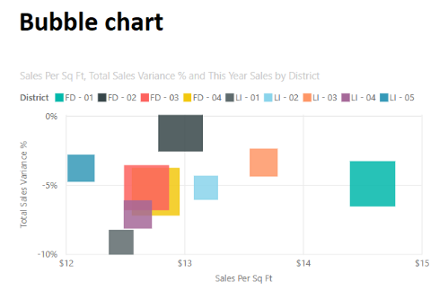
Figure 1: Bubble chart
You can use a bubble chart in many of the same scenarios as a scatter chart. Here are some of the other ways you can use bubble charts:
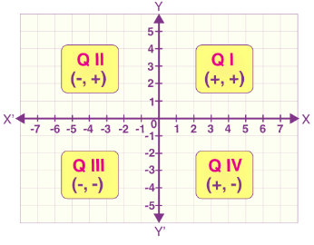
Visually emphasize value differences with variable bubble size.
Support scenarios with three data series that each has sets of values.
Present financial data in a visual rather than numerical form.
Display data with quadrants. A quadrant is a region defined by the two axes (x-axis and y-axis) of the coordinate system. When the two axes, x-axis and y-axis, intersect each other at 90 degrees, the four regions so formed are the quadrants.

Cards, Multi-row Cards
Displays a single value: a single data point. This type of visualization is ideal for visualizing important statistics that you want to track on your Power BI dashboard or report, such as total value, YTD sales, or year-over-year change.
Ideal data: Calculated Measures

Clustered Bar charts

Combo charts:
Is a combination of a column chart and a line chart that can have one or two Y axes.
This chart lets you illustrate correlations between two measures in a single visual, compare multiple measures with different value ranges, and conserve space on a report.

Decomposition tree

Dot plot
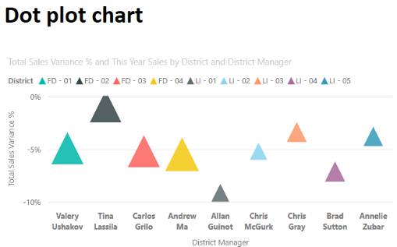
Figure 2: Dot plot chart
Use cases for the dot plot chart are similar to the scenarios described for scatter and bubble charts. The primary advantage of dot plot charts is the ability to include categorical data along the horizontal axis.

Funnel:
Displays a linear process that has sequential connected stages, where items flow sequentially from one stage to the next. Useful when the data is sequential, you want to calculate outcomes by stages, or revealing bottlenecks in a linear process.

Gauge:
A radial gauge chart has a circular arc and displays a single value that measures progress toward a goal or target.

Goals

Key Influencers

KPI

Maps, Filled Maps and Shape Map
A Bubble map displays precise geographical locations of data points on a map. A Fill map uses shading, tinting, or patterns to display how a value differs in proportion across a geographical region. A Shape map use colors to display relative comparisons of geographical regions.

Narrative

Paginated Report

Pie and Donut charts:
Show you the relationship of parts to the whole by dividing the data into segments. From a data analysis perspective, these charts are not useful because interpreting the data that they present can be difficult. Best used for illustrating percentages.

Python
Python is open source code. Means there will be lots of fascinating visualizations out there. By sharing code is much convenient, easy for redistribution. But care to be taken. Some hidden agenda or malicious may introduced to your work

Q&A:
allows you to ask natural language questions and get answers in the form of a visual.

R script

Ribbon chart
Especially useful when there are lots of significant different value across date/region such as multiple sales person, and their sales figure never the same. Eg. first salesperson will top the chart in first year, but second salesperson will top the chart following, third salesperson will top the third year and so on.

Scatter:
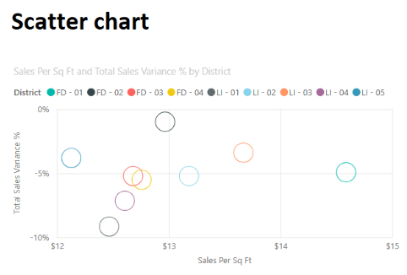
The scatter chart visualization is effective when you are comparing large numbers of data points without regard to time.
It displays data along a horizontal (x) and vertical (y) axis. The chart reveals how numerical values along the two axes are related. When data intersects on the two axes, Power BI displays a data point.
You can analyze data points to identify relationships in your data. Data points are distributed evenly or unevenly across the horizontal axis depending on the chart data. You can set the number of data points up to a maximum of 10,000. Tooltips are available for all data points. The tooltip shows details for the data based on the data represented in the chart.
Scatter charts work well in many scenarios:
- Show relationships between two numerical values.
- Plot two groups of numbers as one series of x and y coordinates.
- Display worksheet data with pairs or grouped sets of values.
- Show patterns in large sets of data.
- Compare large amounts of data points irrespective of time measurements.
- Convert horizontal axis into logarithmic scale.
- Substitute for line charts to enable changing horizontal axis scale.

Slicer:
Used to filter the other visuals on the page. Slicers provide a more advanced and customized way of filtering, in comparison to the Filters pane, which is suited to more basic filtering operations. Different types: list, dropdown, buttons.

Stacked, 100% Stacked bar chart and 100% Stacked column chart

Table and Matrix:
The Table is a grid that contains related data in a logical series of rows and columns. The table supports two dimensions and the data is flat, which means that duplicate values are displayed and not aggregated.
Commonly use with all two dimensional dataset. When each is a record and each column is a variable
The Matrix visualization looks similar to the table visualization; however, it allows you to select one or more elements (rows, columns, values) in the matrix to cross-highlight other visuals on the report page.
Best time to use when showing relationships between two sets of variables

Treemaps:
Displays data as set of nested rectangles. It falls into the same category as the pie and donut charts in terms of their data analysis usefulness.
But it is useful if you want to show attributes by using size and color coding, spot patterns, exceptions, or outliers, or you have large amounts of hierarchical data and a bar chart can’t handle the large number of values.

Waterfall:
The waterfall visualization (also known as a bridge chart) shows a running total as values are added or subtracted, which is useful in displaying a series of positive and negative changes.

More Information
https://learn.microsoft.com/en-us/training/modules/power-bi-effective-reports/5-report-visuals

